## AWS

6. Hosting Website using CloudFront

HARINI L

22BCE5233

<!DOCTYPE html>

<html lang="en">

<head>

<meta charset="UTF-8">

<meta name="viewport" content="width=device-width, initial-scale=1.0">

<title>My Pastel Website</title>

<style>

body {

font-family: 'Helvetica', sans-serif;

margin: 0;

padding: 0;

background-color: #f7f5f2;

color: #444;

scroll-behavior: smooth;

}

nav {

background-color: #ffafcc;

color: #fff;

padding: 16px 0;

position: fixed;

width: 100%;

top: 0;

text-align: center;

font-weight: bold;

z-index: 1000;

}

nav a {

color: #fff;

text-decoration: none;

margin: 0 25px;

font-size: 1.1em;

transition: color 0.3s;

}

nav a:hover {

color: #6a1b9a;

}

header {

background-color: #d1c4e9;

color: #3e2723;

height: 85vh;

display: flex;

flex-direction: column;

justify-content: center;

align-items: center;

text-align: center;

clip-path: polygon(0 0, 100% 0, 100% 85%, 0 100%);

}

header h1 {

font-size: 3em;

margin: 0;

letter-spacing: 4px;

text-transform: uppercase;

animation: fadeInDown 1.5s ease-out;

}

header p {

font-size: 1.2em;

margin: 8px 0 12px;

font-weight: 300;

animation: fadeInUp 1.5s ease-out;

}

header a {

text-decoration: none;

color: #d1c4e9;

background-color: #3e2723;

padding: 10px 20px;

border-radius: 25px;

font-size: 1.1em;

transition: background-color 0.3s, color 0.3s;

animation: fadeInUp 2s ease-out;

}

header a:hover {

background-color: #d1c4e9;

color: #3e2723;

}

@keyframes fadeInDown {

from { opacity: 0; transform: translateY(-30px); }

to { opacity: 1; transform: translateY(0); }

}

@keyframes fadeInUp {

from { opacity: 0; transform: translateY(30px); }

to { opacity: 1; transform: translateY(0); }

}

section {

padding: 40px 20px;

max-width: 1200px;

margin: 0 auto;

text-align: center;

}

#about, #services, #contact {

margin: 25px 0;

background-color: #fff;

padding: 30px;

box-shadow: 0 6px 12px rgba(0, 0, 0, 0.1);

border-radius: 12px;

transition: transform 0.3s, box-shadow 0.3s;

}

#about:hover, #services:hover, #contact:hover {

transform: translateY(-8px);

box-shadow: 0 12px 24px rgba(0, 0, 0, 0.15);

}

h2 {

font-size: 2em;

margin-bottom: 12px;

color: #6a1b9a;

}

h2::after {

content: '';

width: 50px;

height: 3px;

background-color: #6a1b9a;

display: block;

margin: 8px auto 0;

}

p {

font-size: 1.1em;

line-height: 1.6;

margin-bottom: 15px;

}

.service-item {

display: inline-block;

width: 28%;

margin: 15px 1%;

background-color: #fce4ec;

padding: 15px;

border-radius: 10px;

box-shadow: 0 4px 8px rgba(0, 0, 0, 0.1);

transition: transform 0.3s, box-shadow 0.3s;

}

.service-item:hover {

transform: translateY(-8px);

box-shadow: 0 12px 24px rgba(0, 0, 0, 0.15);

}

.service-item h3 {

color: #6a1b9a;

margin-bottom: 10px;

font-size: 1.3em;

}

footer {

background-color: #ffafcc;

color: #fff;

padding: 15px 0;

text-align: center;

}

footer p {

margin: 0;

font-size: 0.9em;

}

footer a {

color: #6a1b9a;

text-decoration: none;

transition: color 0.3s;

}

footer a:hover {

color: #3e2723;

}

</style>

</head>

<body>

<nav>

<a href="#about">About Us</a>

<a href="#services">Our Services</a>

<a href="#contact">Contact Us</a>

</nav>

<header>

<h1>Welcome to Our Site</h1>

<p>Discover a world of pastel elegance</p>

<a href="#about">Learn More</a>

</header>

<section id="about">

<h2>About Us</h2>

<p>We are passionate about delivering creative and high-quality solutions. Our mission is to offer exceptional value through our innovative approach and attention to detail.</p>

</section>

<section id="services">

<h2>Our Services</h2>

<div class="service-item">

<h3>Creative Web Design</h3>

<p>We design visually stunning websites that captivate your audience and enhance user experience with a focus on aesthetics and functionality.</p>

</div>

<div class="service-item">

<h3>Branding & Identity</h3>

<p>Our branding services help you create a strong identity that stands out, building a memorable image for your brand that resonates with your target audience.</p>

</div>

<div class="service-item">

<h3>Effective SEO</h3>

<p>Boost your online presence with our SEO strategies that drive traffic and improve your search engine rankings through targeted and effective techniques.</p>

</div>

</section>

<section id="contact">

<h2>Contact Us</h2>

<p>We’d love to hear from you! Reach out to us with any questions or to discuss your project:</p>

<p>Email: <a href="mailto:hello@pastelwebsite.com">hello@pastelwebsite.com</a></p>

<p>Phone: +1 555 123 4567</p>

</section>

<footer>

<p>&copy; 2024 Pastel Website. All Rights Reserved. | <a href="#privacy">Privacy Policy</a></p>

</footer>

</body>

</html>

Create an S3 Bucket

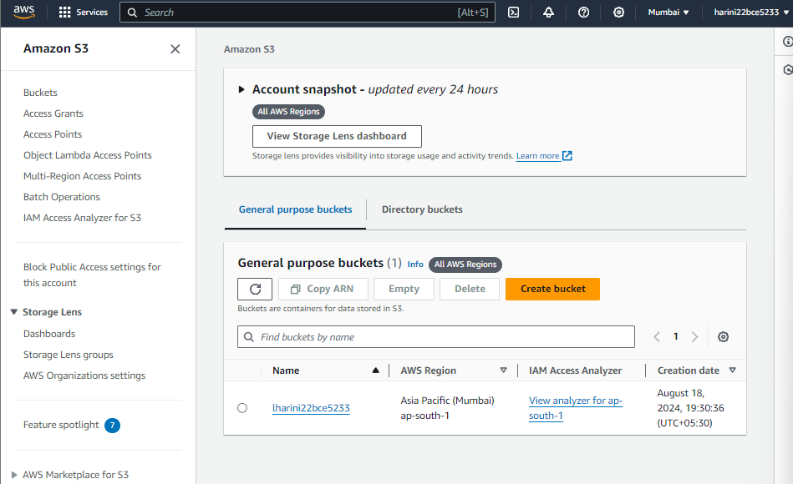

Upload HTML Files to the Bucket

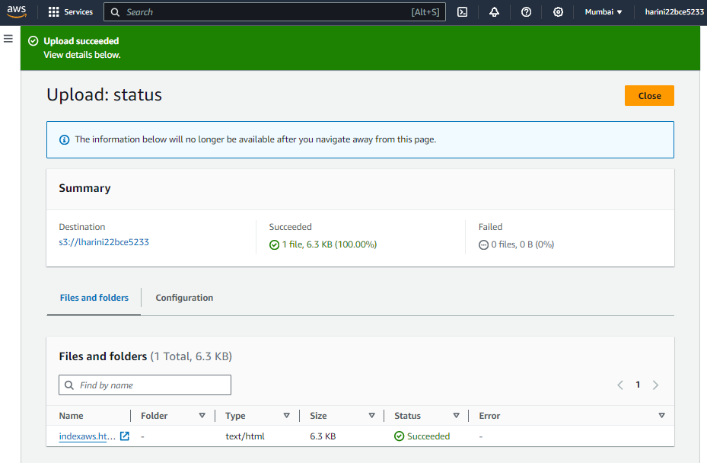

Configure Bucket for Static Website Hosting

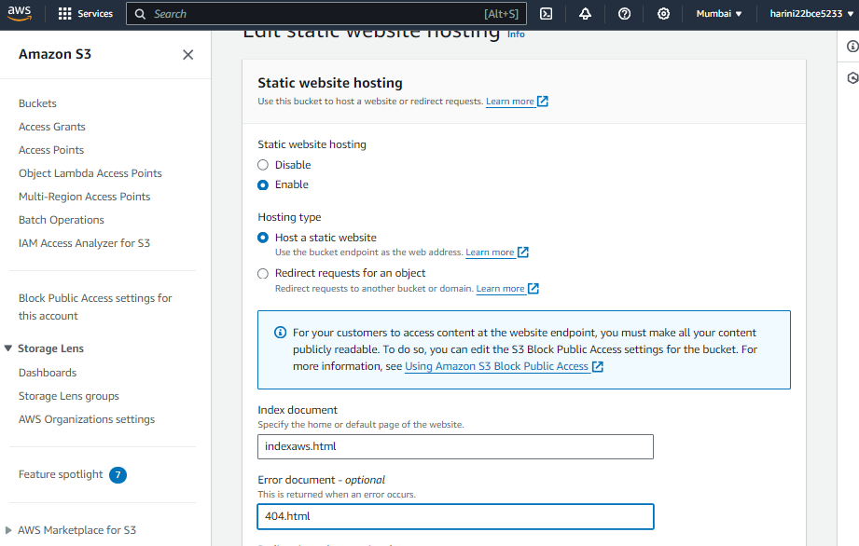

Create a CloudFront Distribution

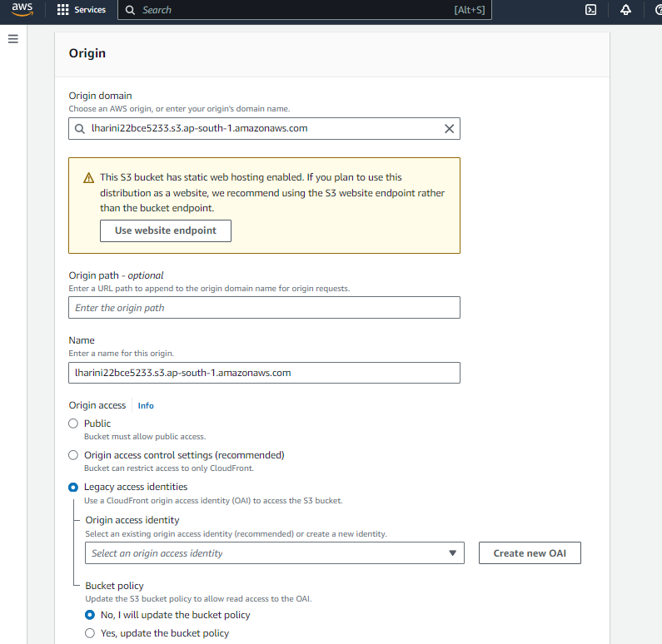

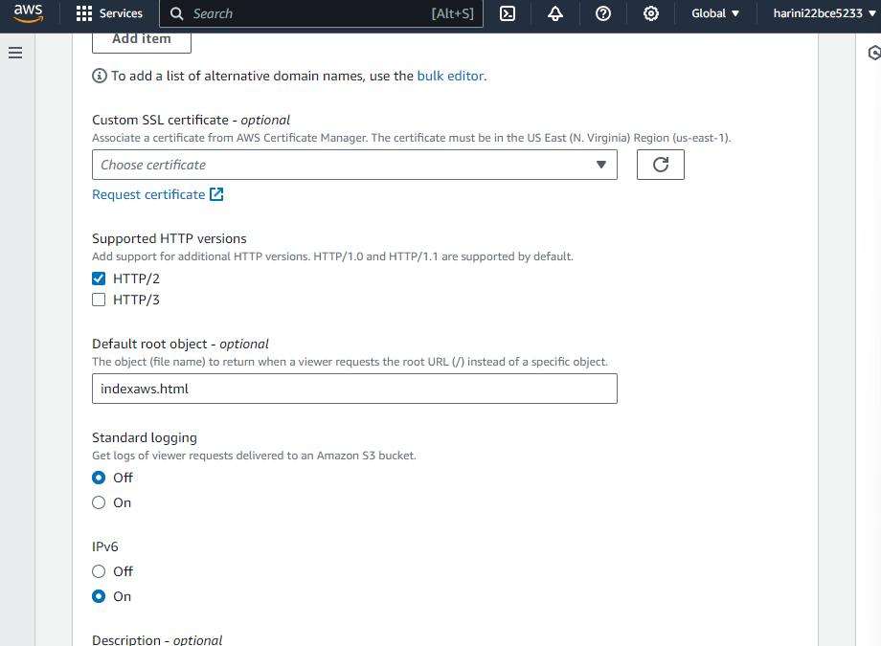

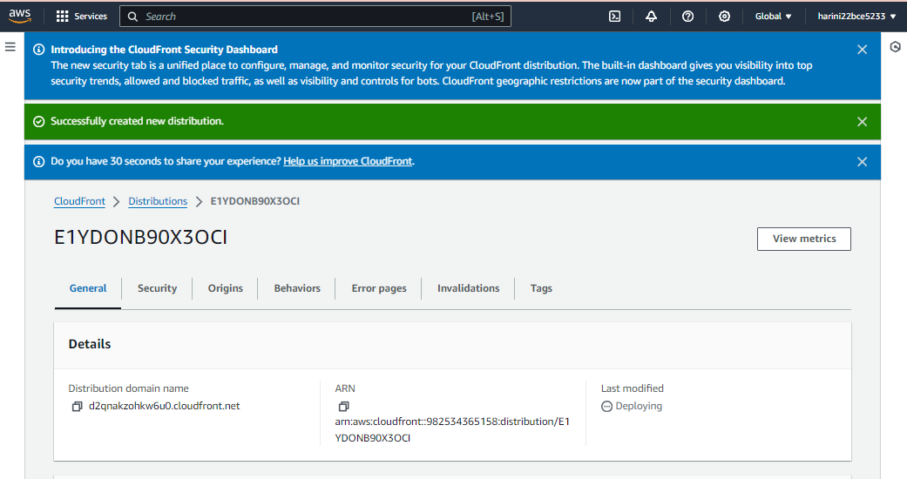

Update the S3 Bucket Policy

{

"Version": "2012-10-17",

"Statement": [

{

"Effect": "Allow",

"Principal": {

"Service": "cloudfront.amazonaws.com"

},

"Action": "s3:GetObject",

"Resource": "arn:aws:s3:::lharini22bce5233/*",

"Condition": {

"StringEquals": {

"AWS:SourceArn": "arn:aws:cloudfront::982534365158:distribution/E1YDONB90X3OCI"

}

}

}

]

}

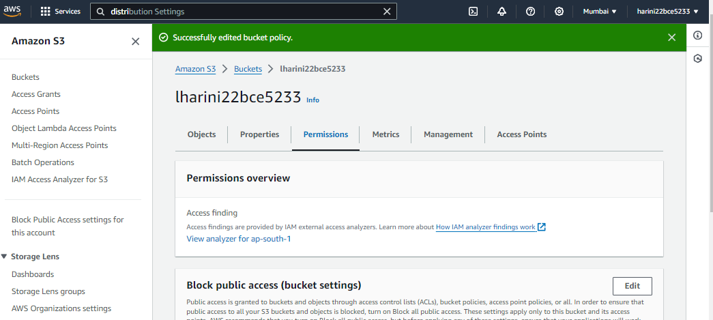

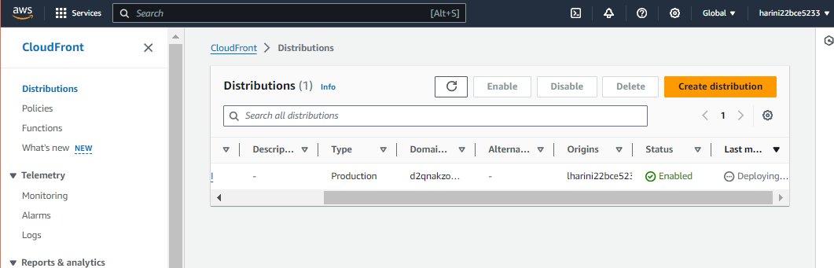

Go to CloudFront, reload the page. Copy the Distribution Domain name and paste it in the browser.

